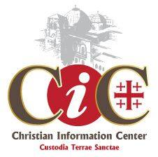**Jaffa Gate - Old City Tel. +972 (0)2 6272692 E-mail: cicinfo@cicts.org; www.cicts.org**

**04.02.25**

**TOURGUIDES**

**CHRISTIAN GUIDES**

**Samir Araman – Licensed Tour Guide**

Tel: +972 526 93 8884 E-Mail: [sam­_araman@yahoo.com](mailto:sam_araman@yahoo.com)

**~~Karina Hernandez - Guida peregrinos hispanohablantes~~**

~~Whatsapp: +972-50-751 5898~~ OUT OF THE COUNTRY

**Iskander Kando – Licensed Tour Guide French and English**

+972 54 467 9550

**Yousef Makhalfeh – Licensed Tour Guide**

Language: English

Tel: +972 54 441 0297 or +972 59 959 6843 E-Mail: [ymakhalfeh@gmail.com](mailto:ymakhalfeh@gmail.com)

**Tony Sabella – Licensed Tour Guide French and English**

+972 54 467 9550

**Michel & Benny Taxi Service / Tour Guides**

+972 54 980 5588 +972 54 347 4669

Airport / Jerusalem - Jerusalem / Airport – FIXED RATE

Premium Taxi Mercedes 300.00 Nis per vehicle up to 4 pax

Van taxi Mercedes 400.00 Nis per vehicle up to 6 pax

**OTHER OR WITH SPECIALITIES**

**Aleza Gittia – Tour guide** Tours in Jerusalem in Spanish and English with a Tour Car (max. 6 pax)

Tel: +972 52 380 1565

**Tzachi Samiya – Lobbyist & Tour guide**

Your expert guide to the corridors of Israel’s Parliament & the alleyways of Jerusalem’s Old City

Tel: +972 50 659 5984 E-Mail: [info@vote120.co.il](mailto:info@vote120.co.il)

**Yaniv Stam – Tour guide**

Languages: English, Hebrew, Italian

E-Mail: [rgneys@gmail.com](mailto:rgneys@gmail.com)

**Sara Tesler – English Guide for Christian + Jewish groups**

Tel: +972 50 735 9633 E-Mail: [sara.tesler@gmail.com](mailto:sara.tesler@gmail.com)

**Yosi Ben-Hanan (Maj. General (Ret.))**

Tel: +972 (2) 6733847 Mobile: +972 (50) 3633217 E-Mail: [yosibh@gmail.com](mailto:yosibh@gmail.com)

20 Koreh – Hadorot St., Talpiot, Jerusalem 9338729 Israel

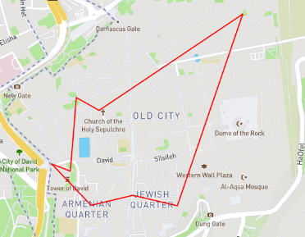**Abraham Hostel**

Offers daily free tours around the Old City (tips-based)

11:00 Tour starts at the entrance to the old city at Jaffa Gate

13:00 Tour ends near the Jaffa Gate

More Information: [Jerusalem Free Tour - Abraham Tours](https://www.abrahamtours.com/tours/free-walking-tour-jerusalem/)

**Irana M.S. Al-Halaseh – Tour guide in Jerusalem**

Tel: 054 441 6376 E-Mail: [halasehrena@yahoo.com](mailto:halasehrena@yahoo.com)

**Jerusalem Walks – Leon Gork, Guide**

Languages: Hebrew, German, Dutch. English, Spanish

Tel: +972 52 380 1867 Website: [www.jerusalemwalks.com](http://www.jerusalemwalks.com)

**Sergio Halbertal – Licensed Tour guide**

Languages: Spanish, Portuguese, English, Hebrew / Luxurious vehicles of all sizes

Leiv Yaffe St. 22/3, 9339053 Jerusalem, Israel

Tel: +972 2 673 7384 or +972 50 538 2870 Email: [sergiohalbertal@hotmail.com](mailto:sergiohalbertal@hotmail.com)

**Joshua Levinson – Licensed Tour guide**

Tel: +972 55 927 2258 Email: [shviljosh@outlook.com](mailto:shviljosh@outlook.com)

**Willma Nazi – Theologist Tour Guide**

Tel: +972 52 537 7633 Email: [Willma.nazi1507@gmail.com](mailto:Willma.nazi1507@gmail.com)

**Yael Rabinovitch – Tour guide**

[yogayael@gmail.com](mailto:yogayael@gmail.com) +972544996432 \ +97 54 499 6432

**Nathalie Szerman - Licensed Tour Guide** English, French, Hebrew

Tel: +972 54 947 4641 Email: [natszerman@gmail.com](mailto:natszerman@gmail.com)

**Eran Tearosh (Chairman)**

The Society for the Heritage of World War I in Israel - 52/1 Nachal Zohar St; Modiin Israel 7174921

Tel: +972 53 536 6777; eMail: [erantearosh@gmail.com](mailto:erantearosh@gmail.com); website: [www.ww1-israel.org](http://www.ww1-israel.org)